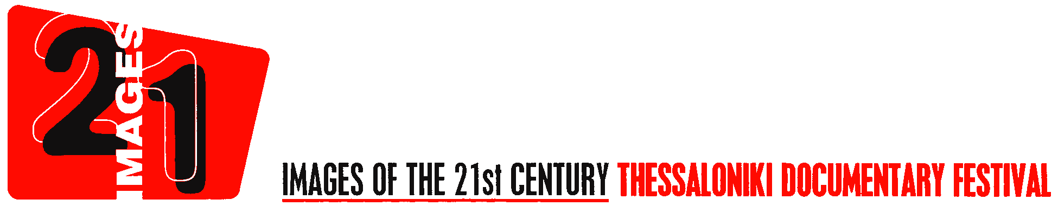

REGULATIONS

The TDF - Thessaloniki Documentary Festival “Images of the 21st Century” is an international Festival of films and videos, taking place annually in the month of March, in Thessaloniki.

Purpose
To introduce and promote the most important documentary productions worldwide, and to create an international forum for the presentations and discussion of emerging media and information technologies.
Organisation
The TDF is organised under the auspices of the Greek Ministry of Culture with the support of the ERT S.A.(Hellenic Broadcasting Corporation), and is administered by the Thessaloniki Film Festival.
Offices
The main offices of the TDF are located jointly in Athens and Thessaloniki.

Period
The 15th^{th} Thessaloniki Documentary Festival will be held in Thessaloniki from March 15th to 24th 2013

Entry Submission
All submissions must be made on-line through the link found on the Festival’s official page (www.filmfestival.gr).
Each submission must include the following materials in electronic form (cd, usb stick etc.)
- 2 DVD copies of the documentary
- Summary of the documentary in English or Greek (up to 200 words)
- Full credit list
- Director’s biographical notes and filmography (film title and production year).
- At least 3 photos of the documentary and 1 photo of the director(s) (in jpg format, 10x15 cm, 300 dpi if possible)
- Any available publicity material

Postal / Shipping Expenses
1) The Festival organization will be liable for insuring the film, from the moment of its arrival at the Festival until its return by carrier.
2) Cost of shipping expenses will be shared among the Festival and the producer.
3) Should a copy be damaged, claims should arrive at the Festival Office no later than one month after the film has been received by the producer and two months after the end of the Festival.
4) The Festival’s liability in case of whole or partial damage of a print during the Festival cannot exceed the value of $300 USD.

Application and Film Selection
1) Deadline for all applications is November 15th, 2012. Entry forms are submitted online.
2) Information requests and DVDs should be sent to:
Thessaloniki Documentary Festival - “Images of the 21st Century”
7 Dion. Areopagitou str., 117 42- Athens, Greece
Tel: +30 210 8706000, +30 210 8706016, Fax: +30 210 6451174
e-mail: documentary@filmfestival.gr
web: www.filmfestival.gr
3) Entrants whose films have been selected will be notified soon after the selection.
4) English subtitled prints must be provided for all films selected.
5) Prints of selected films accompanied by one DVD copy following the exact runtime and subtitles of the screening version (for screening safety reasons) should reach the Festival Offices by February 10th, 2013.
- Films participating in the Festival’s main program must be recent productions of the past 18 months preceding the festival’s dates and not previously shown or been released in Greece.
- All films participating can be 16mm, 35mm, Beta tape (Digital Beta and Beta SP) and/or HD Cam.
- There is no limit in running time.
- The Festival decides and is responsible for the screening schedule of the film (day and hour) during the Festival’s period.
- The Festival has the right to reject any material which does not further the character and objectives of its program.
6) Participation in the Thessaloniki Documentary Festival implies acceptance of the above regulations.

